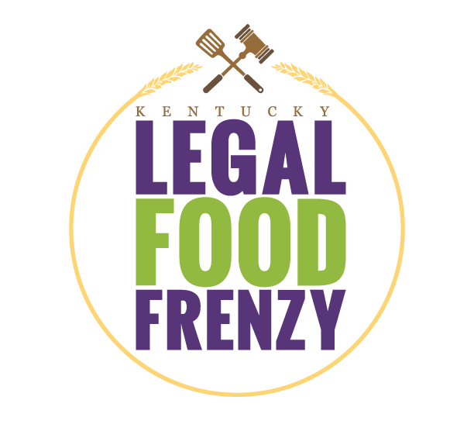
2022 Legal Food Frenzy
Team Lead Packet

Thank you for agreeing to be a Team Lead for the 6th Annual Kentucky Legal Food Frenzy!

What is the Legal Food Frenzy?
The Office of the Attorney General, the Young Lawyers Division of the Kentucky Bar Association, and Feeding Kentucky (formerly the Kentucky Association of Food Banks) have joined forces to create a friendly competition among Kentucky law firms, law schools and legal organizations to support Kentucky’s regional food banks by collecting both food items and monetary donations.

What is our goal?
Law firms, legal offices, and law schools in Kentucky will compete to raise the equivalent of 600,000 pounds of food for Kentucky’s seven regional food banks ($75,000).

What are my responsibilities as Team Lead?
Team Leads have important leadership roles in the Legal Food Frenzy to promote the competition to your colleagues and raise as much food/funds as possible at your office.

- Work with your regional Feeding Kentucky member food bank to plan the Legal Food Frenzy at your office. A representative will be in touch after your register your team at https://p2p.onecause.com/ky-legal-food-frenzy/teams.
- Be inspired! Visit your regional food bank and learn more about hunger in your community. You can receive 100 bonus pounds per person for volunteering at your food bank between 1/26/22 and 3/11/2022.
- Motivate your office to donate as much as possible. See page 3 of this packet for ideas.
- Invite your teammates, community members, friends and family to donate by sharing the donation link: https://p2p.onecause.com/ky-legal-food-frenzy/search. Donations can also be made by check payable to Feeding Kentucky and mailed to PO Box 5522, Frankfort, KY 40602.
- Send a media release to local and regional media to raise awareness of the campaign. A template is available on the Resources page: kyfoodfrenzy.com/resources.
- Pick up a donation barrel from your designated food bank or use your own boxes for 100 bonus pounds.
- Email your End of Campaign Form to your regional food bank on March 16th so the food bank can make plans to receive donated items and to ensure bonus points are tracked.
- Ensure that all donations you plan to deliver to your assigned food bank are received by March 22nd.
- Follow us on Facebook and Twitter: @KyFoodFrenzy, @FeedingKY; promote the campaign on your own social media using #kylff, #KYFoodFrenzy, #FeedTheFrenzy, and #EndHunger. Share photos and information about your team’s competition!

What is the timeline of key dates?
- January 26 – February 6: Sign-up phase on OneCause.
- February 7 – March 11: Legal Food Frenzy campaign! ALL fundraising and food collection must take place during this period. Any money or food collected before or after these dates will not count toward your total unless it is a specially sanctioned event.
- March 16: Return the End of Campaign form to your regional food bank contact.
- March 22: Deadline for food donations to be received by the food bank.
- April 12: Winners announced.
- May 13: Awards ceremony at Kentucky Bar Convention, Lexington.

BONUS POINTS!
- Sign up to compete by February 1st and we will add 100 pounds to your totals.
- Volunteer at your regional food bank between January 26th and March 15th for 100 bonus pounds per volunteer.
- Pick up a donation barrel from your food bank or use your own boxes for 100 bonus pounds.
- 100% participation of all attorneys and staff for 100 bonus pounds.

Prizes
- Grand Prize - Attorney General’s Cup: total pounds equivalent.
- Bar President’s Award: pounds equivalent per attorney.
- KBA Supreme Court district: pounds equivalent per attorney.
- Law school: pounds equivalent.
- Corporate legal department: pounds equivalent.
- Government entity: pounds equivalent.
- Solo law firms (1 – 3 attorneys): pounds equivalent per attorney.
- Small law firms (4 – 10 attorneys): pounds equivalent per attorney.
- Mid-sized law firms (11 – 49 attorneys): pounds equivalent per attorney.
- Large law firms (50+ attorneys): pounds equivalent per attorney. (An individual office of a large firm will compete on its own rather than having donations from each office combined into one firm total).
- VIPs: any individual participant who donates $100 or more to the Legal Food Frenzy will be recognized as a VIP on social media, the Legal Food Frenzy Website, and in print at the award ceremony.

VIPs
Become a VIP!
Those who make or match donations up to $100 or more will be recognized by name on the Legal Food Frenzy website, on social media and in print at the award ceremony. You could even have multiple VIPs from your team. This includes the following:
- Your firm or company
- A managing partner or employee
- A client
- An outside company, group, or individual

Consider Matching
While anyone can simply make a donation $100+ and be recognized as a VIP, we encourage you to increase employee engagement by offering to "match donations."

Why Matching Donations:
- It increases your ability to fight hunger in Kentucky! This will increase employee buy-in! Studies show that mentioning matching has led to a 51% increase in donations from individuals. Every match has the possibility to double or triple the amount of meals Kentucky’s food banks can distribute with your donations.
- Get extra recognition! This is an excellent opportunity to enhance your brand and to gain recognition on the Legal Food Frenzy website.

How do I get more information? Email Info@KyFoodFrenzy.com or call 502-699-2657.

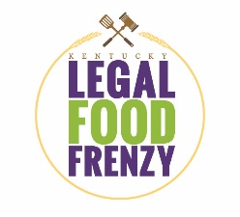
Ideas for Your Food Frenzy

- Be sure to include your organization’s leadership in the implementation and planning of your Legal Food Frenzy efforts. Get the buy-in of your Managing Partner(s). See if they will match donations! The most successful campaigns will be the ones that are able to encourage 100% participation by their lawyers!

- Display daily donation totals in high-traffic areas or announce totals using emails and during staff meeting to keep people up to date and involved.

- Have someone from your regional food bank speak to your office about hunger and how your office’s support will help the community.

- Friendly competition: conduct non-monetary wagering and/or email battles between law firms and/or firm sections, including challenging others in your area to participate on social media.

- Offer incentives for staff members who donate more than 10 cans of food or $20.00.

- Award a prize for all employees who participate if your company wins its category.

- Involve your clients and family members in the Legal Food Frenzy. Ask them to donate on your office’s behalf. Spread the word on social media, by email, and phone calls! #KyLegalFoodFrenzy

- Lunch for the Hungry Day: everyone contributes what they would normally spend on lunch.

- Promote both food and fund donations with a focus on funds. $1 goes a long way with Food Banks’ bulk purchasing leverage. In this competition $1 = 8 pounds.

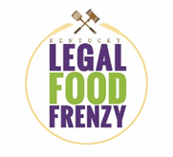
6th Annual Legal Food Frenzy Rules
The contest begins February 7 and ends March 11, 2022. The firm or legal organization contributing the most will win the Attorney General’s Cup, and the firm or legal organization raising the most pounds per attorney equivalent will win the Bar President’s Award. Prizes will also be awarded in eight categories: Sole Practitioner, Small Firm, Medium Firm, Large Firm, Law School, Corporate legal department, Government Entity and KBA Supreme Court District.

- Law firms, law schools, corporate legal departments and government entities sign up to compete at https://p2p.onecause.com/ky-legal-food-frenzy/accept. Law firms with multiple office locations should sign up individually. Each location will compete as its own entity.
- Organizations registering by February 1, 2022 will have 100 pounds added to their score.
- Designated team leads will be contacted by a representative of their regional food bank upon enrollment to make arrangements for collecting food donations.
- Organizations that volunteer at their designated food bank between January 26 and March 15 will have 100 pounds added to their score.
- Each dollar contributed will count as eight pounds of food. The best way to support hunger relief in your community is by making a financial donation to a food bank, which allows them to use the buying power of the Feeding America network to acquire and ship healthy, nutritious food at deeply discounted rates. Donations will support hunger relief efforts in the donor’s county unless otherwise specified.
  - You may donate online at KyFoodFrenzy.com. When entering your gift, you must include the law firm name.
  - Donations via check should be made payable to Feeding Kentucky and mailed to PO Box 5522, Frankfort, KY 40602.
  - Please do not mail cash. Use the online donation form to make donations or mail a check instead.
  - Capital Campaign gifts will not be counted towards the competition
- Please fill out the End of Campaign Information Form and email back to your regional food bank contact by the end of the day on March 16th, 2022.
- All donations must be turned into the food bank no later than March 22 in order to be counted towards the competition. Online and mailed donations count as delivered.
- Winners will be announced on April 12.

For more information, visit KyFoodFrenzy.com, email info@kyfoodfrenzy.com, or call 502-699-2656.

Hunger Facts
1 in 7 Kentuckians – are food insecure, meaning they do not always know where they will find their next meal. Due to the COVID-19 pandemic, it is projected that this number is now nearly 1 in 6 Kentuckians, a 35% increase in typical levels. Kentucky is in the top 10 states with the highest rates of projected food insecurity in 2022 versus 2018.

1 in 6 children in Kentucky are food insecure. This means that nearly 200,000 children in Kentucky have been hungry without access to food in one of the wealthiest nations in the world. This impacts their ability to grow strong physically and pay attention in school.

The Legal Food Frenzy comes at a critical time for our food banks. Nearly all (94 percent) of Kentucky’s food bank client households with school-aged children receive free or reduced-price school lunch through the National School Lunch Program. Only one in thirteen school children who receive free or reduced-priced lunch during the school year has access to such meals during the summer months when school is out. That is prior to the pandemic, when schools were still operating in person.

The Legal Food Frenzy provides a much-needed supply of food and funds to Kentucky’s regional food banks to help families.

Kentucky’s Food Bank Network
Kentucky has 7 regional food banks that serve all 120 counties in partnership with 800 local agencies such as soup kitchens and food pantries. In FY2021, they distributed the equivalent of 79 million meals across the Commonwealth. Over 600,000 Kentuckians receive food assistance from this network each year.

Legal Food Frenzy Email Templates

Sample Email to Colleagues
Dear Colleagues,
The Attorney General and the Kentucky Bar Association’s Young Lawyers Division are partnering with Feeding Kentucky to host the Kentucky Legal Food Frenzy, a competition among all of Kentucky’s law firms and legal organizations to raise food and funds for Kentucky’s food bank network. Whoever raises the most total pounds will be awarded the prestigious Attorney General’s Cup. An additional prize will be awarded for highest total pounds per attorney equivalent. We want to win – and we need EVERYONE to participate however they can, even if we are not physically in the office!
More importantly, we want to provide critical food assistance to our neighbors in need during a time when hunger hurts even more. One in 5 children in Kentucky live in households that are food insecure. While they may receive free or reduced lunch during the school year, summer is hard for these kids. In addition, the pandemic has many families turning to food banks for the first time. The Legal Food Frenzy provides a much-needed supply of food and funds to Kentucky’s regional food banks to help the families of those kids during summer months.
This is an excellent investment – with every $1 donated to Feeding Kentucky, their member food banks can distribute eight pounds of food to Kentuckians facing hunger. Let's rise to the challenge and do our part to reduce hunger in Kentucky! Share with everyone - friends, family, clients! This is everyone’s fight!
Click here to donate between February 7 – March 11. Let’s bring home the Attorney General’s Cup!
Sincerely,
Name

Sample Email to Clients
Dear Clients Name,
The Attorney General and the Kentucky Bar Association’s Young Lawyers Division are partnering with Feeding Kentucky to host the Legal Food Frenzy, a food and fund drive competition among all of Kentucky’s law firms and legal organizations to help end hunger in our Commonwealth. Our (firm/organization) is competing this year, and we are hoping your company will partner with us!
We’re attorneys and we want to win the competition, but most importantly, we want to provide assistance to our neighbors in need:
One in 5 children in Kentucky live in households that are food insecure. In addition, the pandemic has many families turning to food banks for the first time. Donations to Kentucky’s food banks typically slow in the summer months precisely when the need among their clients is greatest. The Legal Food Frenzy provides a much-needed supply of food and funds to Kentucky’s regional food banks to help the families of those kids during summer months.
Here’s how you can partner with us to help:
- Have your company pledge to match monetary donations – you will be recognized on the Legal Food Frenzy website!
- Between February 7 – March 11, share this donation link with your employees and contacts!
- Have your company hold a food drive of non-perishable items, delivering the items to us by March 15
Everything we raise will benefit Kentucky’s food banks. We have a chance to make a REAL impact. For every $1 donated, a food bank can distribute eight pounds of food into the community.
Let's rise to the challenge and do our part to provide our hungry neighbors would nourishing meals.
Sincerely,
Name

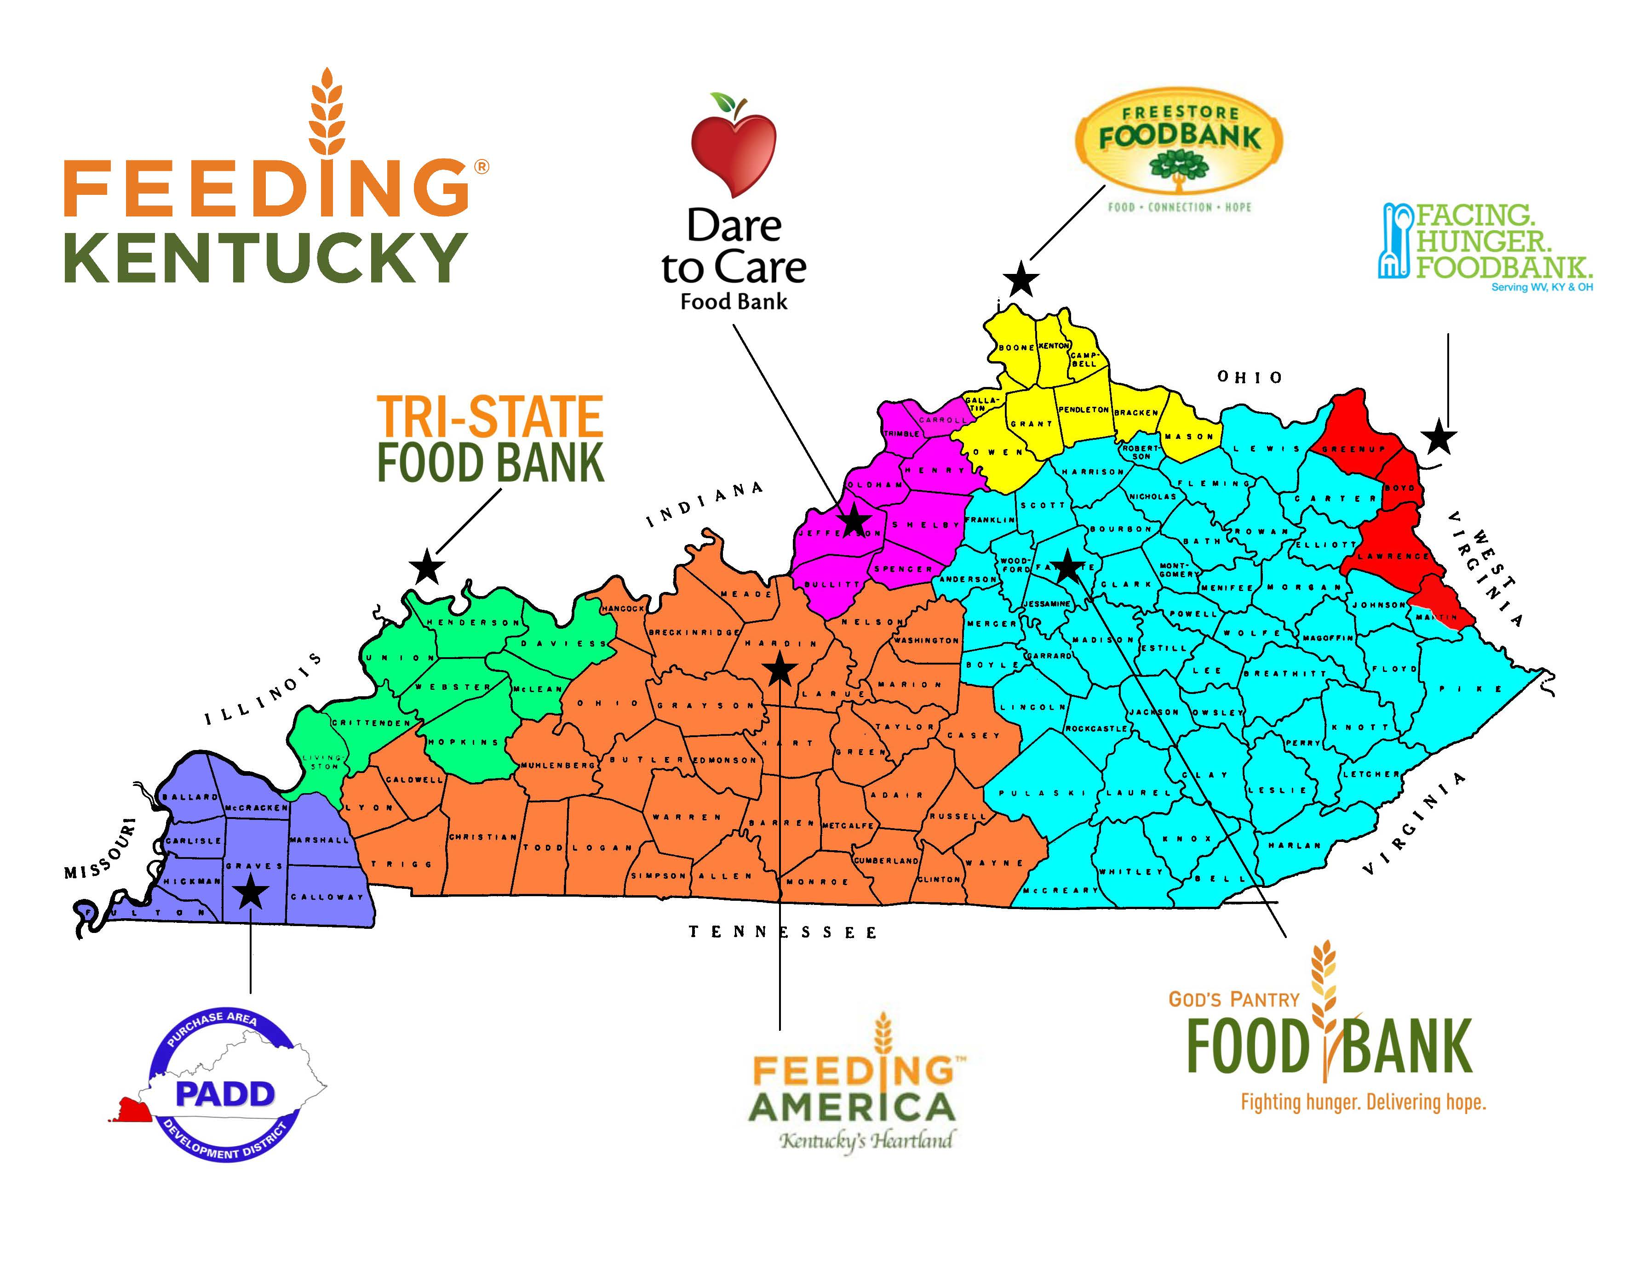
Visit FeedingKy.org for more information.

